Session 3
- Write the full form and one-line use of: HTTP, HTTPS, FTP, SMTP.
Answer:-
Term | Full Form | One-line Use
HTTP | Hyper Text Transfer Protocol | Used to transfer web pages and data between a browser and a web server.
HTTPS | Hyper Text Transfer Protocol Secure | Used to securely transfer data between a browser and a web server.
FTP | File Transfer Protocol | Used to upload and download files between computers over a network.
SMTP | Simple Mail Transfer Protocol | Used to send emails from one mail server to another.

- What is the difference between IPv4 and IPv6? Answer in 2 lines
Answer:-
Difference Between IPv4 and IPv6
IPv4 uses a 32-bit address, such as 192.168.1.1, and has about 4.3 billion addresses.
IPv6 uses a 128-bit address, such as 2001:db8::1, and provides a much larger number of addresses.

- Run nslookup google.com on your system and write down the IP address you get.
Answer:-
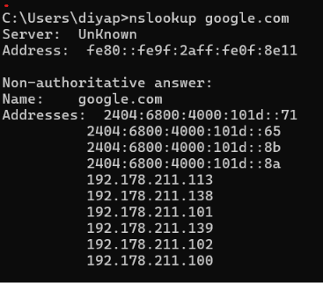

- What do these HTTP status codes mean: 200, 301, 404, 500, 403?
Answer:-
HTTP Status Codes
- 200 – OK: The request was successful.
- 301 – Moved Permanently: The webpage has permanently moved to another URL.
- 404 – Not Found: The requested webpage or resource could not be found.
- 500 – Internal Server Error: There is a problem on the server.
- 403 – Forbidden: The server understood the request but refuses access.

- Explain DNS hierarchy (root, TLD, domain, subdomain) with www.google.com as an example.
Answer:-
DNS Hierarchy
Think of DNS like a tree that helps find a website.
For www.google.com:
- Root (.): The top level of DNS. It directs the request to the correct TLD.
- TLD (.com): Tells us that google.com belongs under the .com domain.
- Domain (google): The main name of the website.
- Subdomain (www): A smaller part of the main domain, commonly used for the web server.

